**Name: Vasavi S Puranik**

**USN:1BM24CS320**

**PROGRAM 2: More Queries on INSURANCE DATABASE**

**Batch:K2**

**1.Demonstrate how you can:**

**o Update the damage amount to 25000 for the car with a specific reg-num for which the accident report number was 12.**

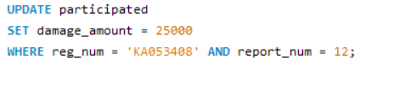

**o Add a new accident to the database**



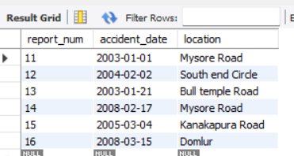

**2. Display the entire CAR relation in the ascending order of manufacturing year.**



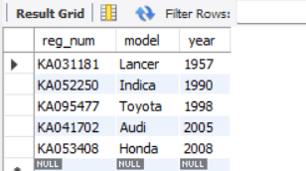

**3. Find the number of accidents in which cars belonging to a specific model**

**involved.**

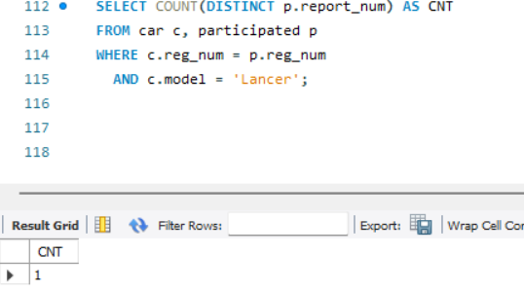

**4. Find the total number of people who owned cars that involved in accidents in 2008.**

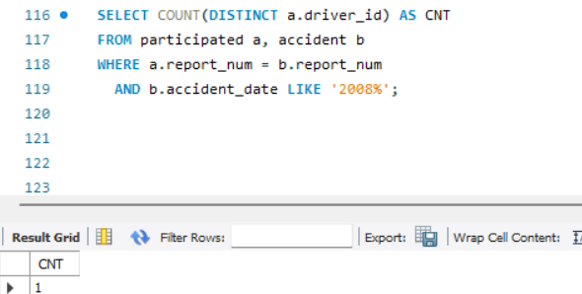

**5.LIST THE ENTIRE PARTICIPATED RELATION IN THE DESCENDING ORDER OF**

**DAMAGE AMOUNT.**

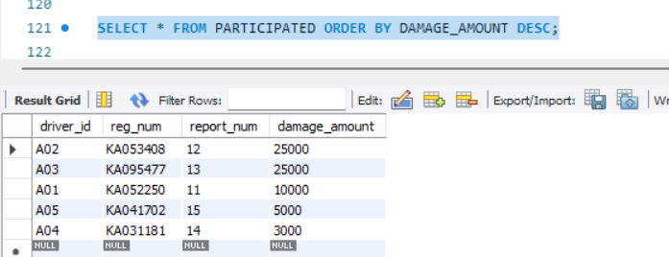

**6. FIND THE AVERAGE DAMAGE AMOUNT**

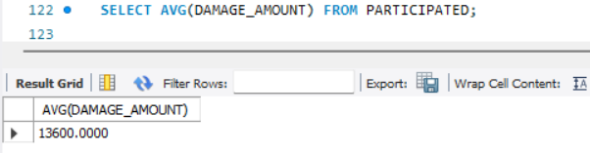

**8. FIND MAXIMUM DAMAGE AMOUNT.**

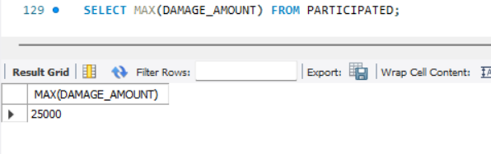

**9. LIST THE NAME OF DRIVERS WHOSE DAMAGE IS GREATER THAN THE AVERAGE**

**DAMAGE AMOUNT.**

